Unit 6 Assignment Instructions – CIS164 
For the Unit 6 Assignment we will be working with dictionaries which allow us to assign key/value pairs for organizing and structuring data.
Please make sure to fully read each question to ensure that you answer each question per the requirement. Also, please ensure that all responses are in complete sentences, free of spelling and grammatical errors.
*Unit 6 Grading Rubric (45 Points):
Assignment Requirements | Maximum Points | Points Earned
1. Dictionary – 1 | 0-5 Points
2. Dictionary – 2 | 0-15 Points
3. Dictionary – 3 | 0-25 Points
Points Deducted for Spelling or Grammatical Errors
Total (Sum of All Points)
*Directions for Submitting Your Assignment:
Complete your assignment ensuring all questions are answered based on the assignment requirements. When the Unit 6 assignment is complete, please save your file in the following format, “Lastname-Unit#.doc” (Example: Smith-Unit6.doc). You may also utilize a Word Processing software such as LibreOffice for assignment completion. In this case the assignment may be saved in .odt format, (Example: Smith-Unit6.odt). Then when ready submit your file to the “CIS 164 – Unit 6 Submit Assignment” activity for grading.

1. Dictionary - 1

- In your own words describe what a dictionary in Python is?
Dictionaries in Python are collections of variables, with any data type, which can be in any order. They are different than lists because lists are ordered by their index.
- In what scenarios do you think the use of a dictionary would be useful in a script?
What makes dictionaries powerful is how you retrieve information from them. Rather than having to iterate through an entire list and comparing the value you’re looking for to the index of the list, you can cut out the middle man and use a Key to look up values in a dictionary. So it’d be useful in a script with large collections of data that need to be regularly retrieved, say a player inventory in a small-scale video game.

2. Dictionary - 2

- Start the PyCharm IDE. Select “File->New Project” on the next screen. Under “Location” change the word “untitled” to “Unit6”. Then click the “Create” button.

- Highlight your project “Unit6” then right click. When you right click a menu will appear, from this menu select New->Python File. Then a dialog box will appear, in the “Name” field of the dialog box type “Unit6Dict1.py”.

- Within your Unit6Dict1.py file, create a dictionary that contains first the value for each month of the year, then include a name to be a value for the key for the month value. For example; {‘January’: ‘Bob’, ‘February’: ‘Mary’ etc…….}

- Next, modify your Unit6Dict1.py file to ask for input from a user to ask what month they would like to display the name for. Then based on the value entered by the user, display the user’s name associated with the month chosen.

- For your script, you will need to provide a screenshot showing your completed script run, and you will also need to submit it in a text file, along with this document.
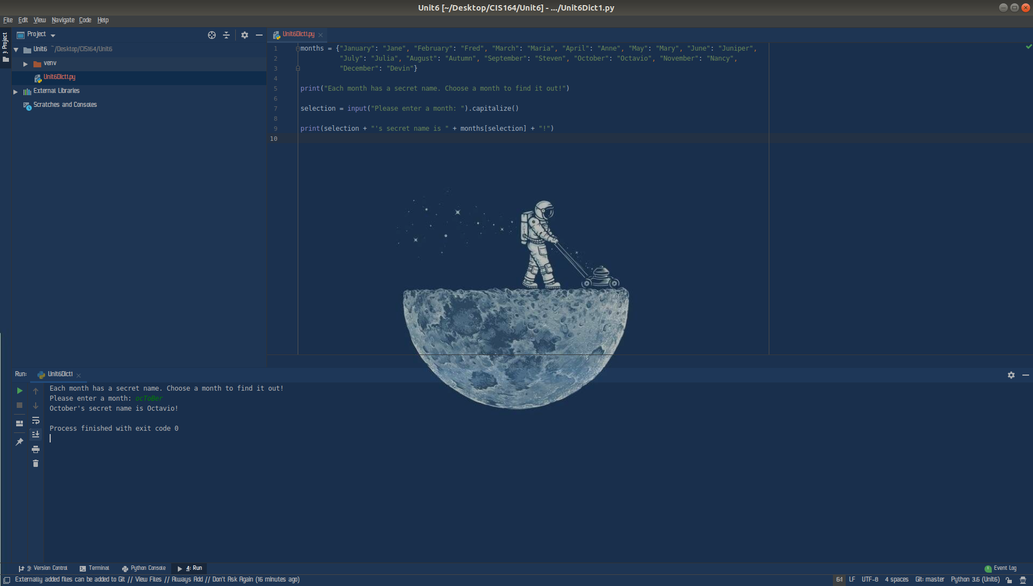

3. Dictionary - 3

- Highlight your project “Unit6” then right click. When you right click a menu will appear, from this menu select New->Python File. Then a dialog box will appear, in the “Name” field of the dialog box type “Unit6Dict2.py”.

- Within your Unit6Dict2.py file, create a function that holds a dictionary that contains first the name of the chapter for our book for chapters 1-5, then include the numeric value for the chapter number. For example; {‘Python Basics’: ‘1’, ‘Flow Control’: ‘2’ etc…….}

- Next, modify your Unit6Dict2.py file to ask for input from a user on what chapter they would like to read in the book. Then based on the value entered by the user, you’re your function to look up the chapter name and display it to the user. In addition, display the URL for the chapter chosen also. For example, if they choose chapter two, the following should be displayed to the user when the script is run:

You have chosen Chapter 2 in our book, Flow Control

https://automatetheboringstuff.com/chapter2/

- For your script, you will need to provide a screenshot showing your completed script run, and you will also need to submit it in a text file, along with this document.

